Prove It! Project
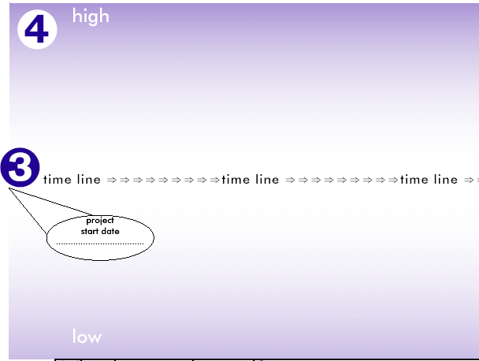



Evaluation Poster

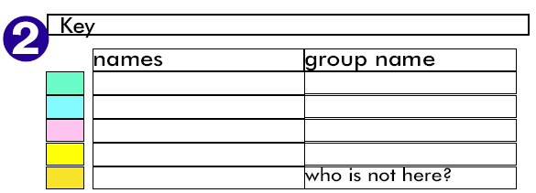

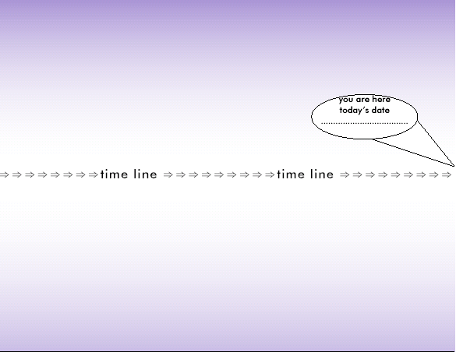

What have we learned?


IMPACTS

LEARNING

Moving forward


What do we need to do to achieve it?

What do we want to achieve next?

This tool has been adapted from a poster that was developed by nef (the new economics foundation) in conjunction with the Shell Better Britain campaign.

